**DAILY ONLINE ACTIVITIES SUMMARY**

|  |  |  |  |  |  |  |  |  |
| --- | --- | --- | --- | --- | --- | --- | --- | --- |
| **Date:** | **02-06-2020** | | | | | **Name:** | **Rohan Mahaveer** | |
| **Sem & Sec** | **6th B** | | | | | **USN:** | **4AL17CS077** | |
| **Online Test Summary** | | | | | | | | |
| **Subject** | | **CGV** | | | | | | |
| **Max. Marks** | | **30** | | **Score** | | | **29** | |
| **Certification Course Summary** | | | | | | | | |
| **Course** | **Cyber security-zero to hero in 9 hrs** | | | | | | | |
| **Certificate Provider** | | | **Udemy** | | **Duration** | | | **9 hrs** |
| **Coding Challenges** | | | | | | | | |
| Problem Statement: 1. Java program to Count number of trailing zeros in product of array  2. Java Program to check whether given number is Armstrong or not | | | | | | | | |
| **Status:** YES, Completed all Programs | | | | | | | | |
| **Uploaded the report in Github** | | | | | **YES** | | | |
| **If yes Repository name** | | | | | <https://github.com/rohanmahaveer/daily-status> | | | |
| **Uploaded the report in slack** | | | | | **YES** | | | |

Online Test Details:

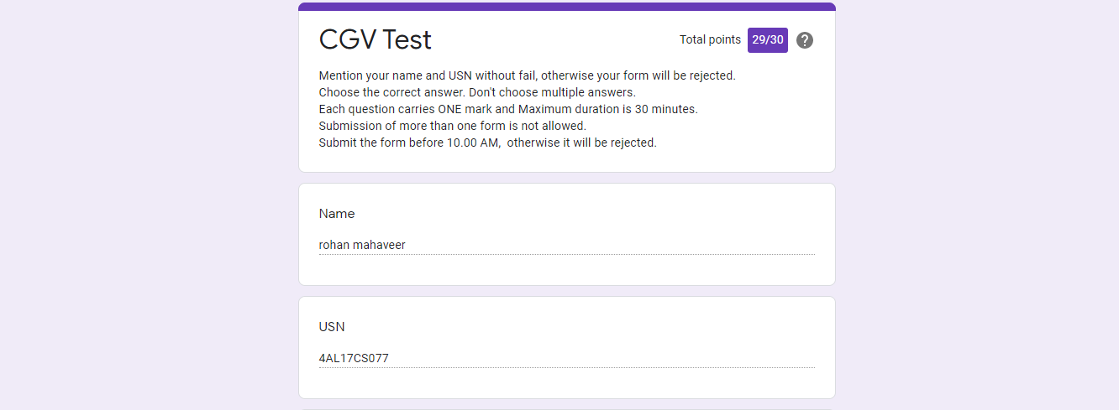

Scored 29 out of 30 in CGV 2nd I.A test

Certification Course Details:

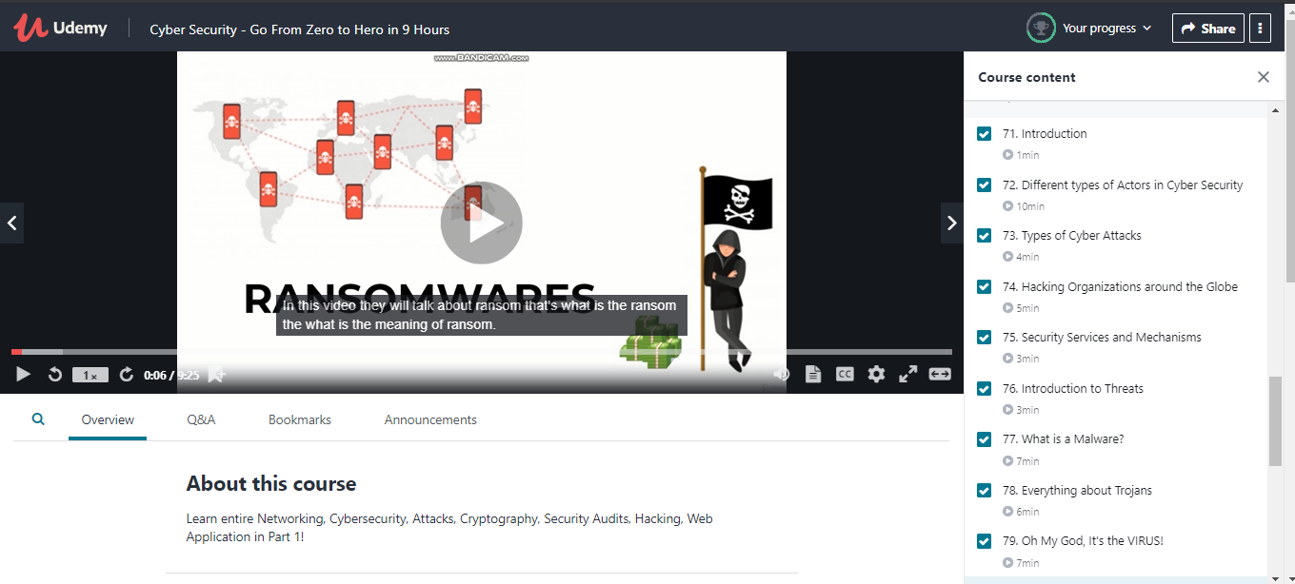

The above course is being taken up by me is based on cyber security. Today in online course I studied about types of cyber attack and different malware. The details of the course and certificate provider are mentioned in the above form.

Coding Challenges Details:

Program1:

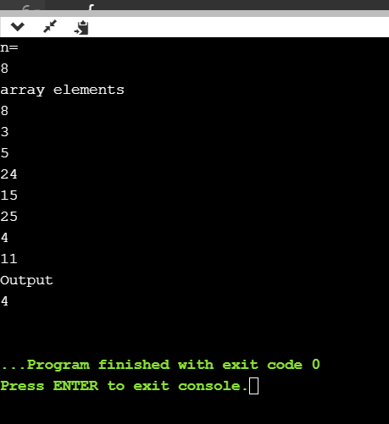

Program2:

